**CSE220: Data Structures (Lab)**

**Fall 2024**

**Lab Quiz - 05**

**Total Marks: 15, Duration: 40 Minutes**

| Name: | ID: | Section: |
| --- | --- | --- |

### **Question 1 [7]**

Given the root of a **binary tree**, write a function to calculate the **sum** of **all** such nodes that have **exactly one child** and **belong to an even level**. Consider the root to be at level 0.

For example, in the following binary tree, nodes that belong to an even level are 30, 18, 27, and 41. Only the node 18 has one child, so the sum will be 18.

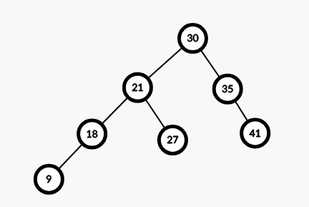

**Question 2 [8]**

Given the root of a **Binary Search Tree (BST)** and a number **x**, write a function to find the **ceil** of **x** in the given BST, where **ceil** means **the smallest value node of the BST which is larger than or equal to x.** If x is larger than the largest node of BST then return -1. Suppose all node values are positive. Following sample inputs and outputs are for the tree given in question 1.

| **Sample Input** | **Sample Output** | **Explanation** |
| --- | --- | --- |
| root, 20 | 21 | Nodes with value larger than 20 are 21, 30, 35, and 41; of them 21 is closest to 20. |
| root, 30 | 30 | Nodes with value larger than or equal to 30 are 30, 35, and 41; of them 30 itself is closest to 30. |
| root, 50 | -1 | 50 is larger than the largest node of the BST (41). |